**DAILY ONLINE ACTIVITIES SUMMARY**

|  |  |  |  |  |  |  |  |  |
| --- | --- | --- | --- | --- | --- | --- | --- | --- |
| **Date:** | **22-6-2020** | | | | | **Name:** | **Poojashree T** | |
| **Sem & Sec** | **8th sem B sec** | | | | | **USN:** | **4al16cs064** | |
| **Online Test Summary** | | | | | | | | |
| **Subject** | | **SMS** | | | | | | |
| **Max. Marks** | | **60** | | **Score** | | | **Not received** | |
| **Certification Course Summary** | | | | | | | | |
| **Course** | **Introduction to R language tutorial** | | | | | | | |
| **Certificate Provider** | | | **Great learning academy** | | **Duration** | | | **3.0hr** |
| **Coding Challenges** | | | | | | | | |
| **Problem Statement:** **1**. **to read the number and compute the series.**  **2. to count the number in th series.**  **3. to check whether number is palindrome or not.**  **4. to find the number between 0 and 50 which are not divisible by 2 and 3.**  **5.micro and array update**  Top of Form | | | | | | | | |
| **Status:completed** | | | | | | | | |
| **Uploaded the report in Github** | | | | | **yes** | | | |
| **If yes Repository name** | | | | | **Poojatgowda** | | | |
| **Uploaded the report in slack** | | | | | **yes** | | | |

**Online test**

Not Received mail

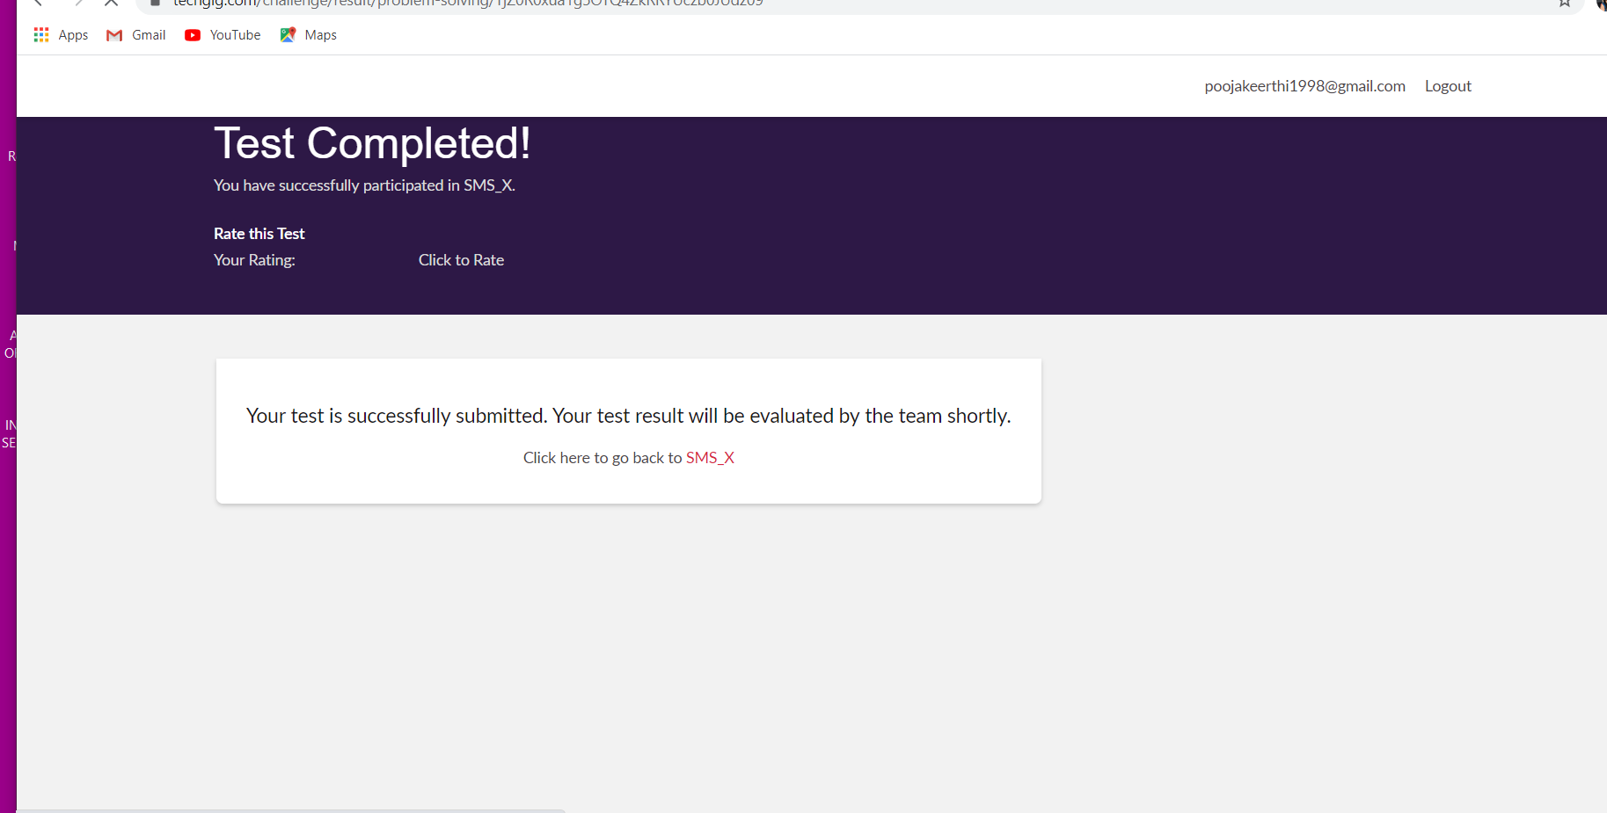

**Certification course**



**Example Program to generate random numbers**

In the below program, we are using the nextInt() method of Random class to serve our purpose.

/* Program: Random number generator

* Written by: Chaitanya from beginnersbook.com

* Input: None

* Output:Random number between o and 200*/

import java.util.*;

class GenerateRandomNumber {

public static void main(String[] args) {

int counter;

Random rnum = new Random();

/* Below code would generate 5 random numbers

* between 0 and 200.

*/

System.out.println("Random Numbers:");

System.out.println("***************");

for (counter = 1; counter <= 5; counter++) {

System.out.println(rnum.nextInt(200));

}

}

}

Output:

Random Numbers:

***************

135

173

5

17

15